Experiment 1: Random forest regression on yelp user information and their rating deviation

To investigate the relation between yelp user information and their rating deviation of a specific restaurant, I select 5 features to define a yelp user (num of friends, num of reviews, num of photos, living area, elite user or not) and fit with their rating deviation to the rating mean of one restaurant. Data were scraped from 71432 yelp users who rated 97 restaurants in atlanta in total.

y = user rating deviation = $\frac{rating - mean(rating)}{mean(rating)}$

I used binary vector for representing the user area (in Atlanta or not) and ‘elite2020’ label (elite user or not)

area_AL:

if user in Atlanta 1

else 0

elite_user:

if user is elite 1

else 0

|  |  |  |  |  |  |
| --- | --- | --- | --- | --- | --- |
| friends | number_reviews | photos | area_AL | elite_user | rating_average |
| 414 | 9 | 0 | 1 | 0 | 0.137585 |
| 0 | 13 | 6 | 0 | 0 | 0.137585 |
| 0 | 44 | 27 | 0 | 0 | 0.137585 |
| 545 | 1379 | 9924 | 0 | 1 | 0.137585 |
| 366 | 328 | 1102 | 0 | 1 | 0.137585 |
| 174 | 71 | 95 | 1 | 1 | -0.08993 |
| 45 | 47 | 246 | 0 | 1 | -0.08993 |
| 189 | 181 | 312 | 0 | 1 | -0.08993 |
| 21 | 71 | 317 | 0 | 1 | -0.08993 |

**part of codes:**

x_train, x_test, y_train, y_test = train_test_split( x_data, y_data, test_size=0.30, shuffle=True, random_state= 0)

rf = RandomForestRegressor(n_estimators=20, random_state=0)

rf.fit(x_train, y_train)

y_pred = rf.predict(x_test)

print('Mean Absolute Error:', metrics.mean_absolute_error(y_test, y_pred))

print('Mean Squared Error:', metrics.mean_squared_error(y_test, y_pred))

print('Root Mean Squared Error:', np.sqrt(metrics.mean_squared_error(y_test, y_pred)))

importances = rf.feature_importances_

print(importances)

**Error (MAE) and feature importance report:**

n_estimator = 5:

Mean Absolute Error: 0.2244267073974103

[0.38660446 0.35181441 0.23128492 0.01882687 0.01146934]

n_estimator = 10:

Mean Absolute Error: 0.2209094613515204

[0.39135136 0.34868485 0.22924052 0.02021638 0.01050689]

n_estimator = 20:

Mean Absolute Error: 0.21921600351026954

[0.38880278 0.35205326 0.22884879 0.01966514 0.01063003]

n_estimator = 30:

Mean Absolute Error: 0.21844714602669382

[0.3908963 0.34822915 0.22996935 0.0204014 0.0105038]

n_estimator = 40:

Mean Absolute Error: 0.21816785556191073

[0.38874473 0.34877435 0.23146044 0.0205317 0.01048877]

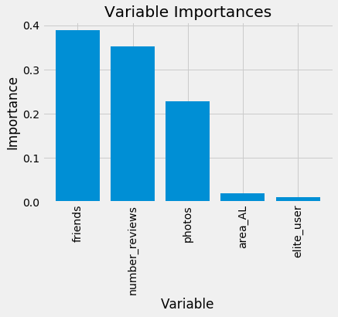

Figure 1. bar chart illustration of feature importance (random forest n_estimator = 20).

**For regression on data after fake date detection (n_estimator = 20):**

Mean Absolute Error: 0.22143776405341808

[0.38474885 0.34113219 0.23889948 0.02485705 0.01036242]

Variable: friends Importance: 0.38

Variable: number_reviews Importance: 0.34

Variable: photos Importance: 0.24

Variable: area_AL Importance: 0.02

Variable: elite_user Importance: 0.01

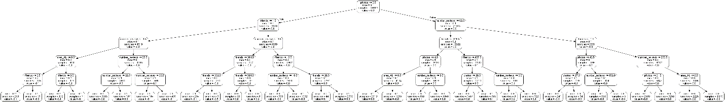

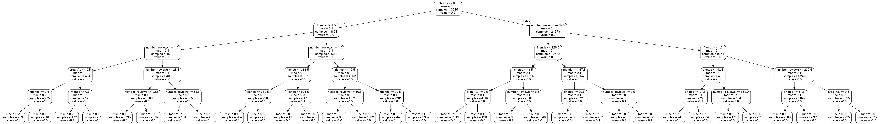

Figure 2. Decision tree plotting for my random forest regressor model.

Experiment 2: Using random forest regression to predict restaurants’ average rating with restaurant features (num of reviews, neighborhood, price level, restaurant type) from 2351 restaurants in Atlanta:

|  |  |  |  |  |  |  |  |  |  |  |  |
| --- | --- | --- | --- | --- | --- | --- | --- | --- | --- | --- | --- |
| review_count | average_rating | neighborhood_Buckhead | neighborhood_East Lake | neighborhood_Grant Park | price_$ | price_$$ | price_$$$ | price_$$$$ | type_african | type_american | type_asian |
| 6  +737 | 4 | 0 | 0 |  | 0 | 1 | 0 | 0 | 0 | 1 | 0 |
| 53 | 4.5 | 0 | 0 |  | 0 | 1 | 0 | 0 | 0 | 1 | 0 |
| 995 | 4 | 0 | 0 |  | 0 | 1 | 0 | 0 | 0 | 0 | 0 |
| 749 | 4 | 0 | 0 |  | 0 | 1 | 0 | 0 | 0 | 0 | 1 |
| 2 | 5 | 0 | 0 |  | 0 | 0 | 0 | 0 | 0 | 1 | 0 |
| 434 | 4 | 0 | 0 |  | 0 | 1 | 0 | 0 | 0 | 1 | 0 |
| 1341 | 4 | 0 | 0 |  | 0 | 1 | 0 | 0 | 0 | 0 | 0 |
| 143 | 4 | 0 | 0 |  | 0 | 1 | 0 | 0 | 0 | 1 | 0 |
| 225 | 4 | 0 | 0 |  | 0 | 1 | 0 | 0 | 0 | 0 | 0 |

n_estimators = 100

Mean Absolute Error: 0.5956120883758985

Variable: review_count Importance: 0.4387

Variable: type_fastfood Importance: 0.0624

Variable: neighborhood_Buckhead Importance: 0.0507

Variable: price_1 Importance: 0.0427

Variable: neighborhood_Westside / Home Park Importance: 0.0348

Variable: neighborhood_West End Importance: 0.0315

Variable: price_2 Importance: 0.0253

Variable: neighborhood_Morningside / Lenox Park Importance: 0.022

Variable: type_asian Importance: 0.0197

Variable: type_american Importance: 0.0194

Variable: neighborhood_West Paces Ferry / Northside Importance: 0.0191

Variable: type_meat Importance: 0.0188

Variable: neighborhood_Ormewood Park Importance: 0.0186

Variable: type_mexican Importance: 0.0175

Variable: type_cafe Importance: 0.0164

Variable: neighborhood_Kirkwood Importance: 0.015

Variable: neighborhood_East Lake Importance: 0.0141

Variable: type_european Importance: 0.0137

Variable: type_bar Importance: 0.0132

Variable: type_caribbean Importance: 0.012

Variable: type_others Importance: 0.0112

Variable: type_breakfast Importance: 0.0111

Variable: type_bakery Importance: 0.0103

Variable: price_3 Importance: 0.0095

Variable: type_specificDiet Importance: 0.0089

Variable: neighborhood_Poncey - Highland Importance: 0.0071

Variable: type_african Importance: 0.0055

Variable: neighborhood_Reynoldstown Importance: 0.0054

Variable: type_mediterranean Importance: 0.0041

Variable: type_salad Importance: 0.004

Variable: neighborhood_Old Fourth Ward Importance: 0.0039

Variable: type_foodmarket Importance: 0.0038

Variable: type_buffet Importance: 0.0034

Variable: price_4 Importance: 0.0024

Variable: neighborhood_Lake Claire Importance: 0.0014

Variable: type_festival Importance: 0.001

Variable: type_mideastern Importance: 0.001

Variable: neighborhood_Grant Park Importance: 0.0005

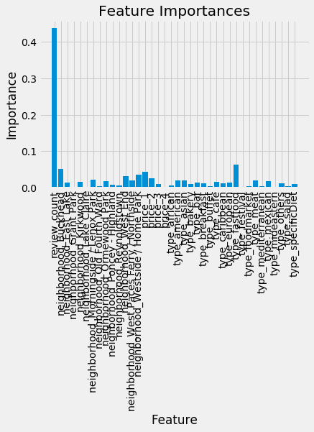

Because the importance of review numbers to restaurant’s rating is a lot, I dropped this feature and fit with random forest regression model again:

n_estimators = 100

Mean Absolute Error: 0.5900246939434137

Variable: type_fastfood Importance: 0.1677

Variable: neighborhood_Buckhead Importance: 0.0957

Variable: price_$ Importance: 0.0875

Variable: price_$$ Importance: 0.0754

Variable: neighborhood_West End Importance: 0.0563

Variable: neighborhood_Westside / Home Park Importance: 0.0369

Variable: neighborhood_Morningside / Lenox Park Importance: 0.0299

Variable: type_mexican Importance: 0.0299

Variable: neighborhood_West Paces Ferry / Northside Importance: 0.0278

Variable: neighborhood_Ormewood Park Importance: 0.0257

Variable: neighborhood_Kirkwood Importance: 0.0251

Variable: neighborhood_East Lake Importance: 0.0232

Variable: type_breakfast Importance: 0.023

Variable: type_meat Importance: 0.0229

Variable: type_others Importance: 0.0226

Variable: type_asian Importance: 0.0206

Variable: type_american Importance: 0.0199

Variable: price_$$$ Importance: 0.0193

Variable: neighborhood_Poncey - Highland Importance: 0.019

Variable: type_specificDiet Importance: 0.0165

Variable: type_bakery Importance: 0.0163

Variable: type_cafe Importance: 0.0163

Variable: type_bar Importance: 0.0148

Variable: type_european Importance: 0.0148

Variable: type_caribbean Importance: 0.0147

Variable: type_african Importance: 0.0118

Variable: price_$$$$ Importance: 0.0092

Variable: type_mediterranean Importance: 0.0081

Variable: type_buffet Importance: 0.0077

Variable: type_foodmarket Importance: 0.0076

Variable: neighborhood_Reynoldstown Importance: 0.0072

Variable: neighborhood_Old Fourth Ward Importance: 0.0067

Variable: type_salad Importance: 0.0059

Variable: neighborhood_Lake Claire Importance: 0.0058

Variable: type_festival Importance: 0.0042

Variable: type_mideastern Importance: 0.0025

Variable: neighborhood_Grant Park Importance: 0.0019

